### **Objective:**

The main goal of this project was to design and build an Event Management & Ticketing System (EMTS) by following all the major phases of the Software Development Life Cycle (SDLC). We wanted our approach to be structured, professional, and well-documented just like in a real-world software development environment.

Through this system, we aimed to simplify and automate every step of event management from creating and publishing events to booking tickets, handling payments, and managing communication between organizers and participants. Our objective went beyond just building a working platform; we wanted to apply proper software engineering principles throughout the process.

To achieve this, we managed our project using Jira for task and sprint planning, maintained version control through a dedicated GitHub organization, and practiced collaborative development with clearly defined roles for each team member. This allowed us to experience how real teams plan, design, implement, and deliver a complete system efficiently and systematically.

### **Introduction:**

In today’s world, managing events manually can be time-consuming, error-prone, and inefficient especially when it comes to handling large audiences, ticketing, and communication. With this challenge in mind, our team set out to create the Event Management & Ticketing System (EMTS) a complete, web-based platform designed to simplify how events are created, managed, and experienced.

The purpose of EMTS is to provide a centralized and automated system where event organizers can easily publish their events, manage ticket sales, monitor participant data, and communicate with attendees. On the other hand, users can conveniently browse events, purchase tickets, and receive real-time updates all through a modern, secure, and user-friendly interface.

From the very beginning, we decided to follow a structured Software Development Life Cycle (SDLC) to ensure that our project was developed in a systematic, organized, and professional manner. We followed the Agile Scrum model, dividing our work into six sprints, each with specific goals and deliverables. Every sprint focused on a particular phase of the SDLC starting from requirement analysis and system design to implementation, testing, and final deployment.

To manage our workflow effectively, we used Jira Software to plan and track our progress. We created Epics, Stories, Tasks, Bugs, and Subtasks to break down the entire project into smaller, manageable units. Each story or task was assigned to a specific team member, and new branches were created in GitHub corresponding to each task or bug fix. This ensured that our work was not only organized but also traceable from planning to implementation and final integration.

We also formed a GitHub Organization named “Event Management & Ticketing System (EMTS)”, which served as our central collaboration hub. All code contributions, reviews, and merges were managed within this shared environment, ensuring transparency and teamwork. Each member contributed through pull requests and participated in regular sprint reviews to evaluate progress and resolve issues.

Technically, EMTS was developed using the Laravel framework, powered by PHP and MySQL, with Blade templates for the frontend and Tailwind CSS for a clean, responsive design. The system follows the MVC (Model–View–Controller) architecture, which ensures a clear separation between the user interface, business logic, and data management layers.

To make the application modular, efficient, and easy to maintain, we implemented several software design patterns throughout development. The Observer Pattern was used to automate real-time ticket updates and notifications without manual triggers, while the Service Layer Pattern handled business logic separately from controllers to maintain clean architecture. The Repository Pattern abstracted database operations and improved query performance, and the Strategy Pattern was applied to manage dynamic role transitions and flexible ticketing logic. For secure user operations, the Command Pattern powered the password reset system, and the State Pattern managed payment workflows with safe, traceable transitions between pending, paid, and refunded states. Additionally, the Component Pattern was used to build reusable interface elements, enhancing consistency across pages.Together, these design choices helped us build EMTS as a scalable, maintainable, and production-ready system, reflecting both academic rigor and real-world engineering practices.

Our project followed the Agile Scrum methodology, managed through Jira, where we created and tracked Epics, Stories, Tasks, Bugs, and Subtasks over six sprints. Each task was linked to a corresponding GitHub branch within our EMTS organization repository, ensuring continuous collaboration and version control. This combination of structured SDLC practices, collaborative tools, and modern design patterns helped us develop EMTS as a complete, production-level web application while gaining hands-on experience in real-world software development.

## **Software Development Life Cycle (SDLC) Phases for EMTS:**

### **Requirement Analysis Phase :**

The requirement analysis phase marked the true beginning of our Event Management & Ticketing System (EMTS) project. At this stage, our goal was to clearly understand what the system should do, who would use it, and how it should perform. This phase laid the groundwork for everything that followed in the SDLC.

To ensure accuracy and structure, we used Jira Software as our central platform for planning and requirement management. We created a dedicated Jira project with the key EMTS, based on the Scrum template, which aligned perfectly with our Agile development approach. Using Jira allowed us to organize, prioritize, and visualize every requirement in an iterative, collaborative way.

Each major feature of the system was defined as an Epic, which was then broken down into smaller, actionable items such as Stories, Tasks, Bugs, and Subtasks. In total, we documented 30 Epics and more than 70 issues covering all technical and functional areas from backend and database logic to frontend UI, testing, security, and API integration. Every task was labeled with specific tags like backend, frontend, performance, or security to help the team stay organized and focused on their domain responsibilities.

During this stage, we identified the key components of the EMTS platform:

* Authentication System – for secure user login, registration, and access control
* Event Management – for event creation, modification, and approval
* Ticket System – for booking, seat availability, and QR-based validation
* Payment Gateway – for handling secure online transactions
* Notification Service – for sending automated emails and SMS updates
* Admin & User Dashboards – for management and analytics visualization
* Reporting & Analytics – for event insights, user statistics, and revenue tracking

We also analyzed and documented non-functional requirements including performance, scalability, security, and maintainability to ensure the system would remain efficient and reliable under real-world conditions. These quality factors were tracked using dedicated Jira labels like performance, testing, and security, making them measurable and easy to verify during testing.

Alongside Jira, our team also established a GitHub Organization named Event Management & Ticketing System (EMTS) to manage version control and collaborative development from the very beginning. This organization was directly linked with Jira, allowing each feature branch or pull request to correspond to a specific Jira issue key (e.g., EMTS-4 Setup the Project, EMTS-5 Authentication Module). This early integration ensured that our requirement tracking and codebase were always synchronized, fostering transparency between planning and implementation teams.

To visualize our structured requirements, we referred to the Jira Backlog List View, where all Epics and Stories were organized and linked to their respective Sprints.

The List View, shown below, provided a high-level overview of Epics and their associated stories, showing how the system’s main features were grouped and prioritized.It offers a glimpse into the detailed structure of our project setup and progress tracking.

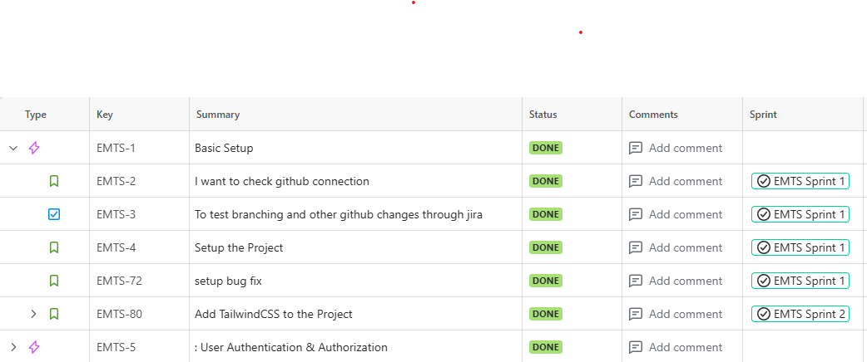

By the end of this phase, we had a complete, well-structured set of functional and non-functional requirements, all mapped to sprints, tasks, and corresponding GitHub branches. This ensured that when development began, every team member understood their objectives, dependencies, and deliverables setting the stage for a smooth and organized SDLC process.

### **System Design Phase :**

After finalizing the system requirements, our team transitioned into the system design phase, where we converted ideas and goals into structured, technical blueprints. This phase was all about visualizing how the entire system would function how each component would interact, what data would flow between modules, and how users would experience the final product.

At the core of our design, we chose the Laravel framework, powered by PHP for backend logic and MySQL for database management. For the frontend, we implemented Blade templates along with Tailwind CSS to create a responsive and consistent user interface. Laravel’s built-in MVC (Model–View–Controller) architecture ensured a clear separation between the user interface, business logic, and data layers, making the codebase modular, organized, and easier to maintain.

To improve scalability, flexibility, and long-term maintainability, we incorporated several software design patterns throughout the system:

* Observer Pattern: Enabled real-time updates for ticket status and notifications without manual refresh.
* Service Layer Pattern: Centralized the application’s business logic, keeping controllers lightweight and focused.
* Repository Pattern: Simplified data access and improved database query optimization.
* Strategy Pattern: Supported flexible user roles and customizable event-handling strategies.
* Command Pattern: Managed secure, encapsulated operations like password resets and checkout handling.
* State Pattern: Controlled transitions in payment and ticket booking statuses to prevent inconsistencies.
* Component Pattern: Allowed reusability of UI elements across multiple views, ensuring consistent design and performance.

These patterns collectively ensured that EMTS was not just functional but also adaptable and easy to extend, which is crucial for a long-term, production-level system.

To complement the architectural design, we created a set of system modeling diagrams that visually represented data movement, user interaction, and process flow. These diagrams helped both the development team and stakeholders understand the overall system structure before implementation began.

The design phase also included system modeling diagrams, such as:

**Data Flow Diagrams (DFDs) :**

To visualize the internal logic and data movement of EMTS, we designed a series of Data Flow Diagrams (DFDs) using the Yourdon notation.

#### 

#### **Context Level DFD :**

The Context Level DFD provides an overview of the entire Event Management & Ticketing System as a single process.It illustrates how users, administrators, event organizers, and the notification system interact with the platform through actions like registration, event approval, booking, and report generation.

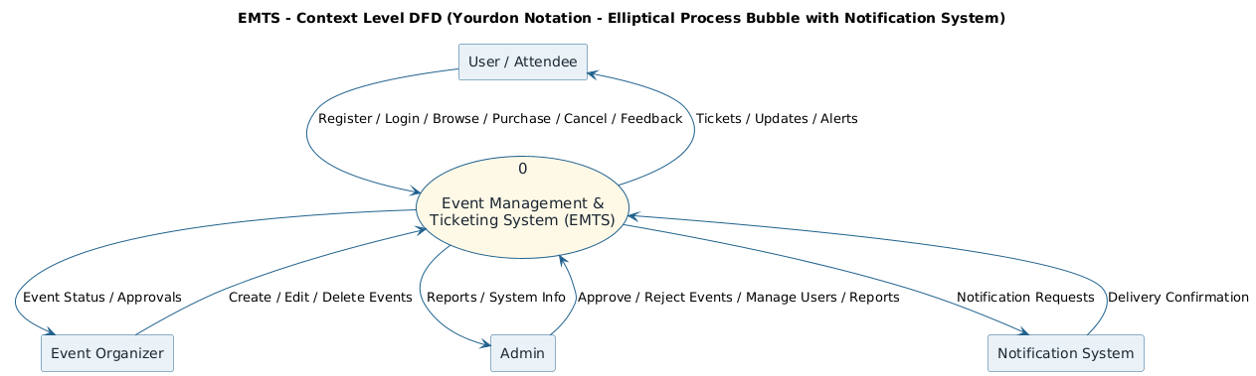

**Figure 1:** Context Level DFD showing external entities and their interactions with EMTS.

#### **Level 0 DFD :**

The Level 0 DFD breaks the system into six main modules — User Management, Event Management, Ticket Management, Notification Management, Admin Management, and Support & Reports.

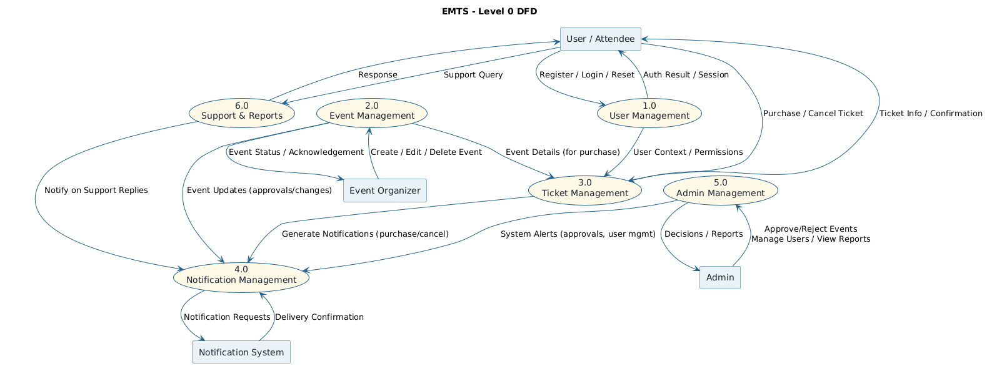

**Figure 2:** Level 0 DFD depicting primary processes and their data exchanges across modules.

#### **Level 1 DFDs (Subsystem-Level Decomposition):**

To further detail each functional area, we designed individual Level 1 DFDs for the major modules of EMTS.

**Level-1 DFD — 1.0 User Management:**

This diagram illustrates user-related functions such as registration, login, password reset, and logout.It also shows how authentication data and reset tokens are stored and validated through interaction with the notification system.

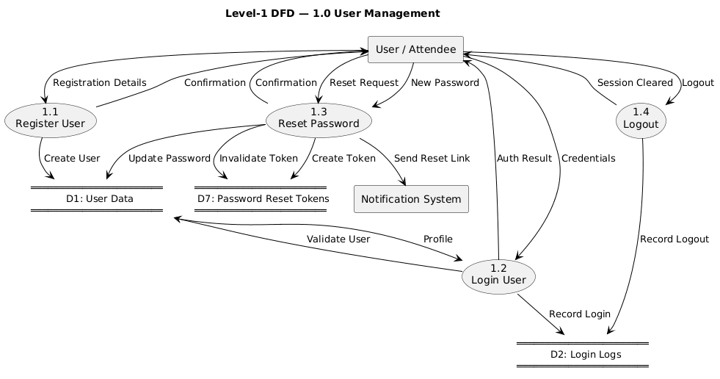

**Figure 3**: Level-1 DFD for User Management module showing login, registration, and password flow.

##### **Level-1 DFD — 2.0 Event Management :**

This module allows event organizers to create, edit, delete, and view events.It also includes approval workflows where the admin validates or rejects submitted events and triggers notifications for status updates.

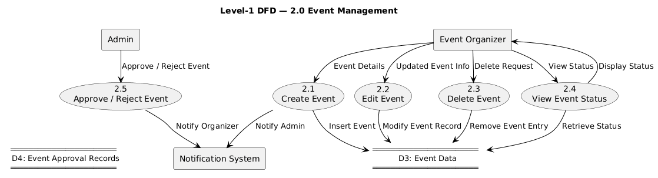

**Figure 4:** Level-1 DFD for Event Management module illustrating event CRUD and approval flows.

##### **Level-1 DFD — 3.0 Ticket Management**

The Ticket Management module covers processes such as purchasing, viewing, and canceling tickets.It integrates with the Notification and Event modules to confirm bookings, manage cancellations, and update ticket availability.

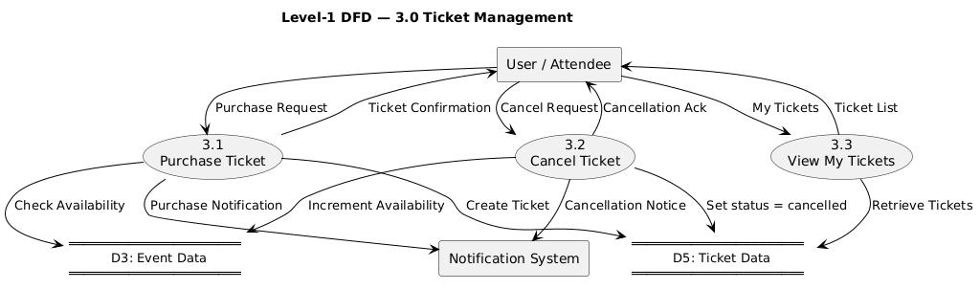

**Figure 5:** Level-1 DFD for Ticket Management module showing ticket lifecycle and notifications.

##### **Level-1 DFD — 4.0 Notification Management:**

This module handles all real-time communications within the system — generating and delivering notifications for users, organizers, and admins.

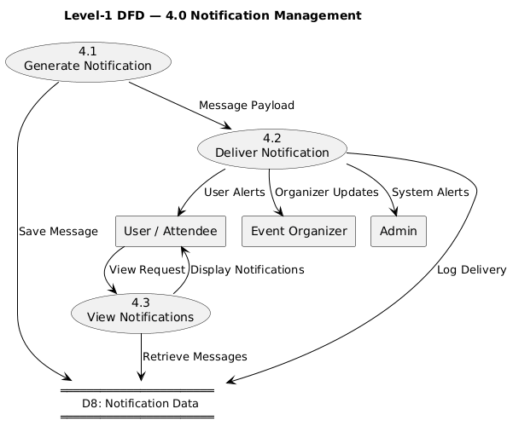

**Figure 6:** Level-1 DFD for Notification Management module displaying message flow and logging.

**Level-1 DFD — 5.0 Admin Management:**

This diagram focuses on admin-level operations such as approving/rejecting events, managing users, and viewing system reports.

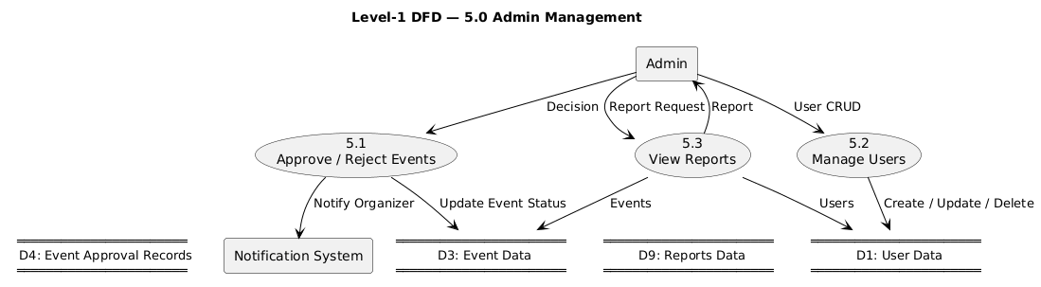

**Figure 7:** Level-1 DFD for Admin Management module showing event approval, user management, and reporting.

##### **Level-1 DFD — 6.0 Support & Reports:**

This module demonstrates how users can submit support queries and how admins generate system reports.

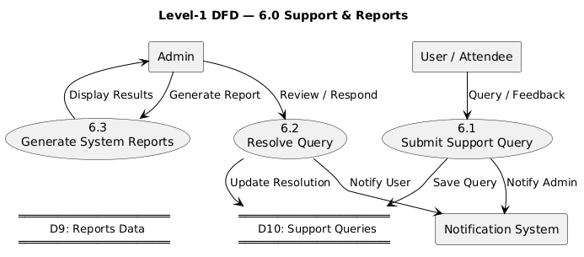

**Figure 10:** Level-1 DFD for Support & Reports module outlining feedback and reporting flows.

**Use Case Diagram :**

The Use Case Diagram provides a functional overview of how different users interact with the Event Management & Ticketing System (EMTS).

It identifies the main actors User/Attendee, Event Organizer, and Admin and maps out their roles and actions such as registering, creating events, booking tickets, and managing approvals.

This diagram helped define the system’s core functionalities and user responsibilities before moving into detailed design.

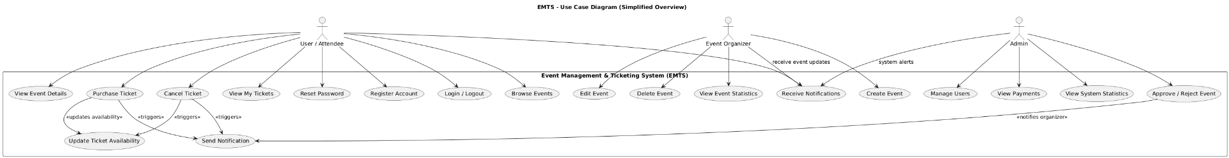

**Figure 9:** Use Case Diagram showing main actors and their interactions with EMTS.

### 

### 

### 

### 

### 

### 

### 

### 

### 

### **Sequence Diagrams :**

The Sequence Diagrams illustrate the step-by-step flow of interactions between users, system components, and controllers across different modules of the Event Management & Ticketing System (EMTS).They visually represent how requests are processed, data is exchanged, and actions are triggered between the frontend (Browser, Routes, Controllers) and backend (Database, Services, Observers) components.

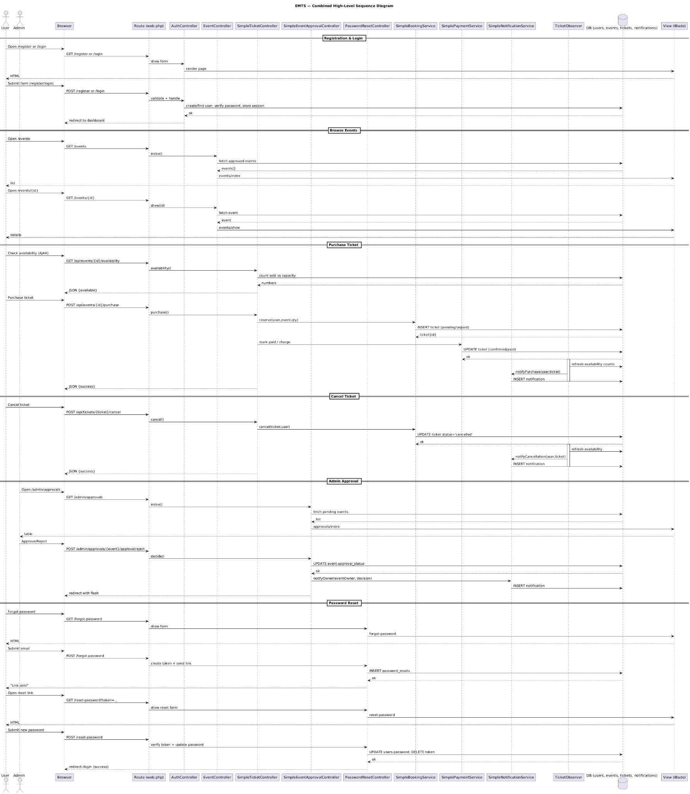

**Figure 10:** Combined High-Level Sequence Diagram Overview of all major workflows

**Registration & Login Flow:**

This diagram outlines how users register and log in to the system. It shows validation, database record creation, and session management handled through controllers and middleware to ensure secure authentication.

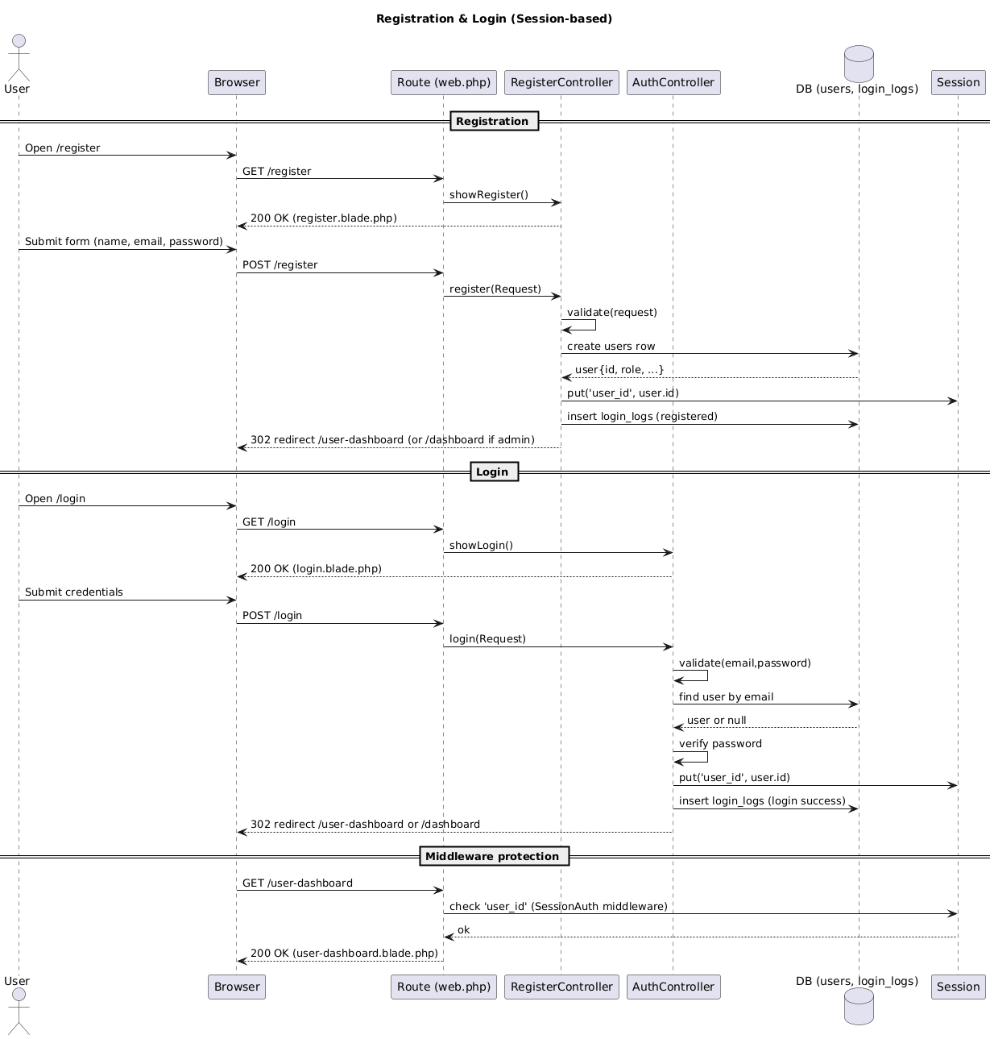

**Figure 11:** Registration & Login Flow

**Browse Events & View Details:**

It illustrates the user flow for browsing approved events and viewing event details. The sequence highlights how the system retrieves data from the events table and renders it dynamically using Blade templates.

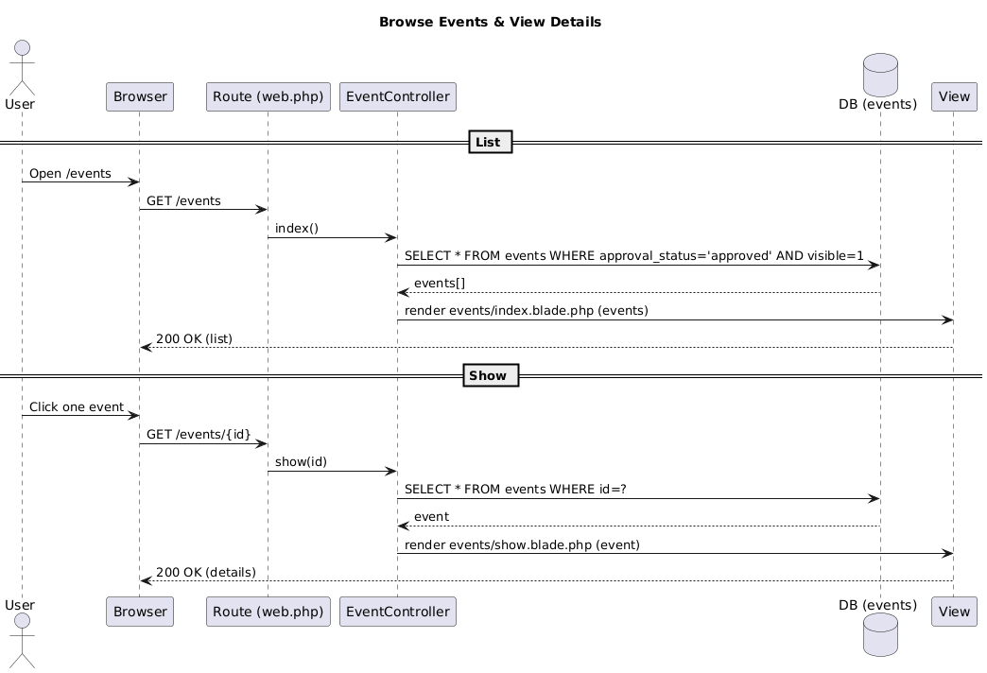

**Figure 12:** Browse Events & View Details

**Ticket Purchase Flow:**

This sequence explains the complete ticket purchase lifecycle from checking availability and reserving seats to processing payments and generating notifications. It integrates the Observer and Service patterns for real-time updates and modular handling.

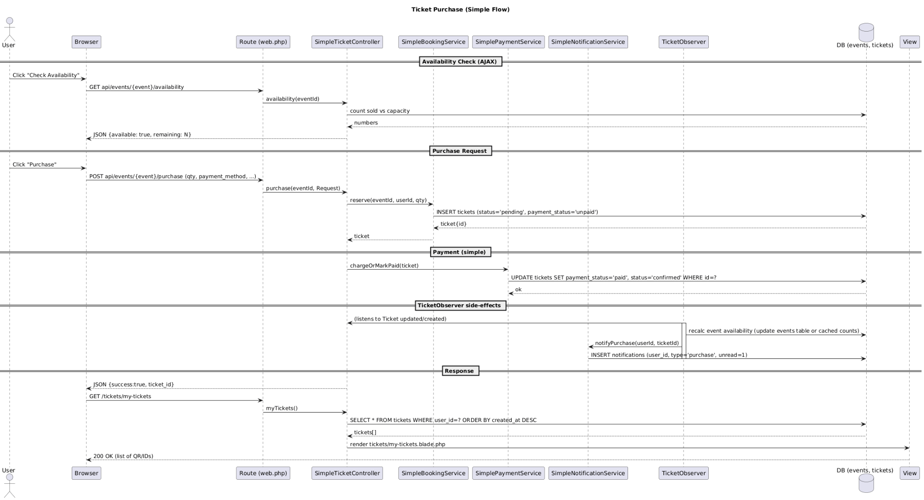

**Figure 13:** Ticket Purchase Flow

**Admin Event Approval Flow:**

This diagram captures the process through which admins review, approve, or reject event requests. It emphasizes the communication between the Admin Controller, database, and Notification Service for status updates.

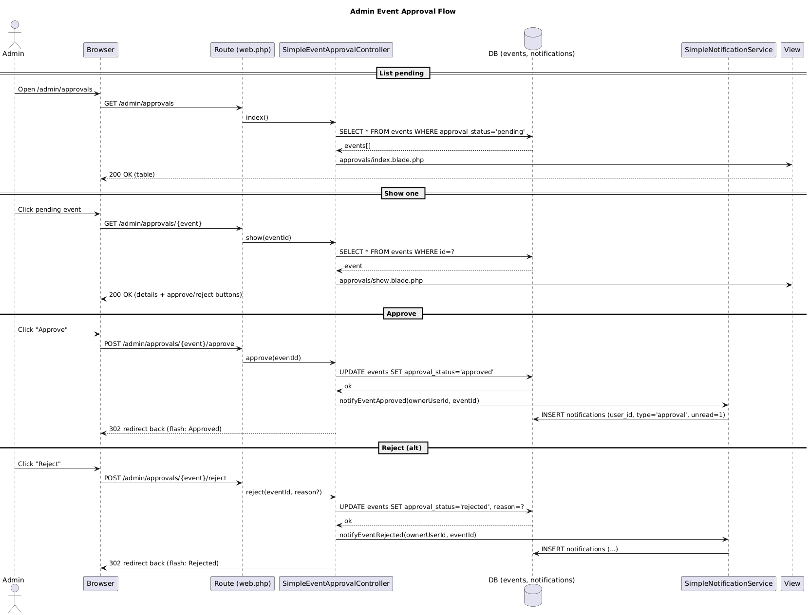

**Figure 14:** Admin Event Approval Flow

**Ticket Cancellation Flow:**

It depicts how a user cancels a ticket, triggering status updates in the ticket database and notification alerts for both the user and event organizer. The TicketObserver ensures consistency across related tables.

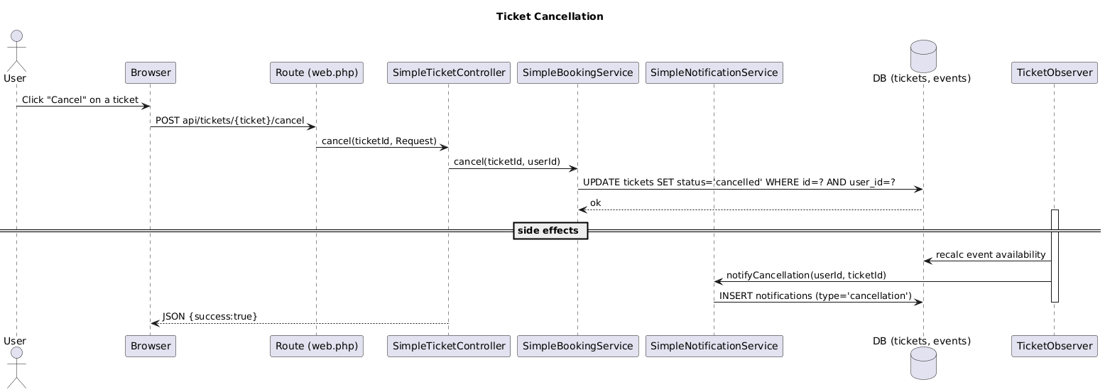

**Figure 15:** Ticket Cancellation Flow

**Password Reset Flow:**

This diagram explains the password recovery mechanism from requesting a reset link via email/SMS to submitting a new password. It ensures security through token validation and expiry checks handled by the PasswordResetService.

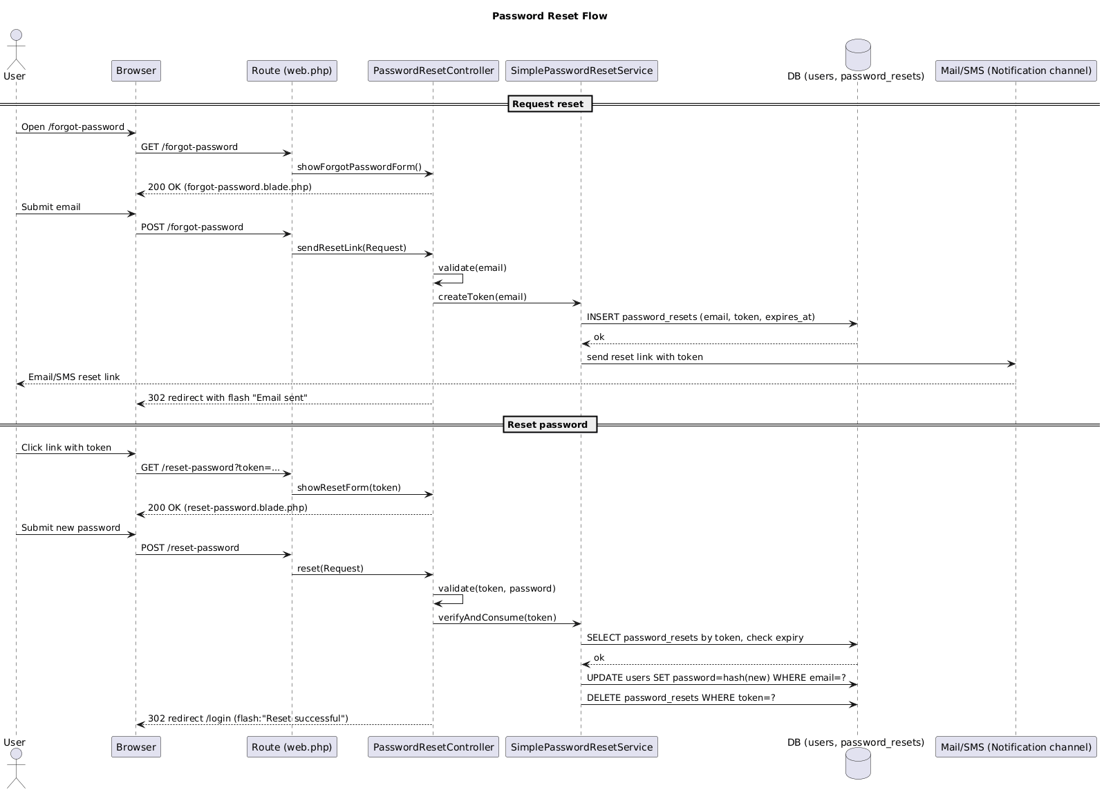

**Figure 16:** Password Reset Flow

### **Activity Diagram:**

The Activity Diagram represents the overall flow of operations within the Event Management & Ticketing System (EMTS) from user login to ticket purchase and cancellation.

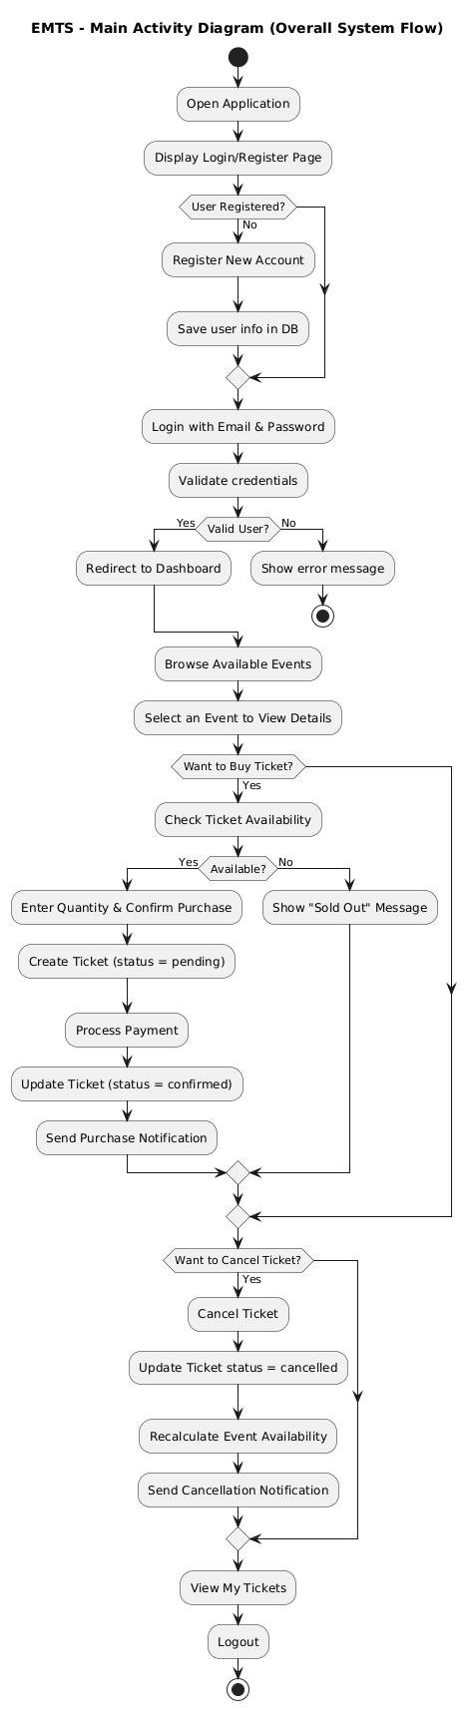

**Figure 17:** Main Activity Diagram showing the overall EMTS system flow.

### **Class Diagram:**

The Class Diagram illustrates the structural design of the EMTS platform, showing how core components interact within the MVC and Service architecture. It connects the main entitiesUser, Event, Ticket, Notification, and others demonstrating how users create events, purchase or cancel tickets, and receive notifications. The diagram also highlights the role of the Observer pattern, where the TicketObserver automatically updates event availability and triggers notifications, and the Service pattern, which centralizes logic in dedicated classes like Booking, Payment, and Notification services. Controllers communicate with these services to keep the system modular and maintainable, while one-to-many relationships between users, tickets, and events ensure data consistency across modules.

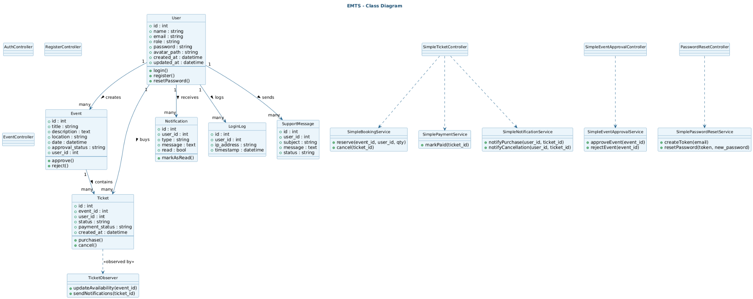

**Figure 18:** Class Diagram showing EMTS structure and interrelationships among core entities and services.

### **Entity–Relationship Diagram (ERD)**

The Entity–Relationship Diagram illustrates the logical data model of the Event Management & Ticketing System (EMTS). It defines how key entities such as User, Event, Ticket, Notification, LoginLog, and SupportMessage are related within the database. Each user can create multiple events, purchase multiple tickets, and receive several notifications, reflecting one-to-many relationships. The ERD helped ensure proper normalization, maintain referential integrity, and provide a clear blueprint for implementing the MySQL schema during development.

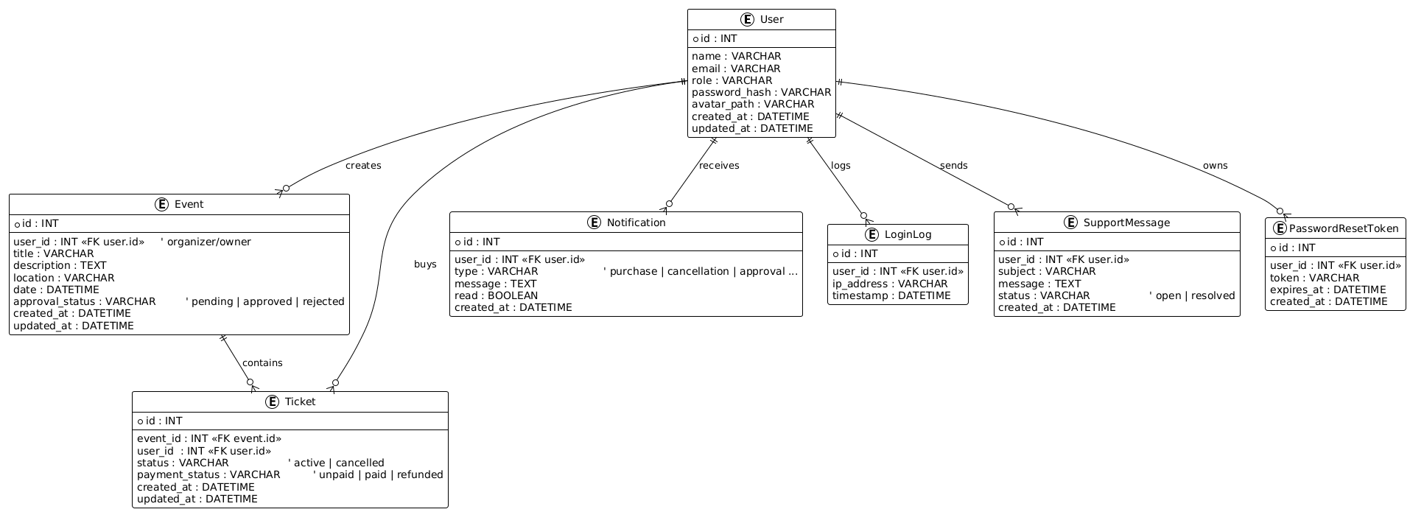

**Figure 19:** Entity–Relationship Diagram depicting the core data model and relationships among EMTS entities.

Each diagram played a vital role in translating abstract requirements into a clear, interconnected system structure. Together, they provided a visual roadmap for the development team, ensuring that every module from user authentication to ticket booking was properly planned, connected, and documented before a single line of code was written.

By the end of this phase, EMTS had a complete technical foundation a well-defined architecture, a clean database schema, and a blueprint for interaction between users, components, and services. This thorough design process ensured that the next phase implementation could begin smoothly, with minimal ambiguity and maximum clarity.

### **Implementation Phase :**

The implementation phase marked the transition from design blueprints to a fully functional system. Using the Laravel framework, we developed the Event Management & Ticketing System (EMTS) in a modular and structured way, ensuring scalability, maintainability, and adherence to the MVC architecture.

Each component of the system was developed as an independent module to allow parallel work among team members. Every module corresponded to a Jira Story or Task, and a separate GitHub branch was created for each one (for example, EMTS-105-Add-eye-icon-in-register-page). This method ensured that all progress was traceable, reviewed, and aligned with the Agile sprint plan.

Our GitHub Organization, titled Event Management & Ticketing System (EMTS), served as the central hub for version control and collaboration. Team members cloned the repository, worked on their assigned feature branches, and created pull requests for review and merging. This approach reduced conflicts, maintained transparency through commit history, and reflected professional software engineering practices. Integration with Jira linked each code update to its respective task, enabling continuous synchronization between planning and implementation.

The project followed Laravel’s MVC structure, with controllers managing business logic, models handling data operations, and Blade templates defining the frontend presentation. Middleware was implemented for secure access control across different user roles, while Laravel migrations streamlined database creation and updates without manual SQL intervention.

The core modules implemented during this phase included:

* User Authentication: Implemented secure login, registration, password reset, and role-based access using middleware.
* Event Management: Enabled event creation, editing, approval workflows, and publication control for organizers and admins.
* Ticket Booking System: Managed seat availability, ticket purchase, and cancellation while maintaining real-time updates through the Observer pattern.
* Notification System: Automated sending of confirmation emails, event updates, and cancellation alerts to users and organizers.
* Checkout & Payment: Integrated secure payment handling with proper state tracking (pending, paid, refunded) using the State and Command patterns.
* Admin Dashboard: Provided administrators with analytical views, event monitoring tools, and user management functionalities.

For the frontend, we used Blade templates and Tailwind CSS to maintain a clean, responsive, and visually consistent interface. These templates ensured the system remained lightweight and mobile-friendly, improving the overall user experience.

By the end of this phase, EMTS had evolved into a fully operational web-based platform that seamlessly connected users, organizers, and administrators transforming our conceptual designs into a practical, real-world solution ready for testing and deployment.

### **Testing Phase**

The testing phase played a crucial role in ensuring that every component of the Event Management & Ticketing System (EMTS) functioned reliably and met all requirements defined earlier in the SDLC. Rather than waiting until the end, we adopted a continuous testing approach, integrating testing activities into each sprint. This helped us identify and resolve issues early, maintaining system stability throughout development.

A combination of manual testing and Laravel’s built-in automated testing tools was used to validate individual modules and overall system behavior. Each new feature or update underwent thorough checks before being merged into the main branch. All detected bugs and anomalies were documented in Jira, recorded as individual issues under their respective Epics (for example, EMTS-10, EMTS-53, EMTS-59). This ensured full traceability between testing outcomes and the development tasks they were linked to.

Key testing activities performed during this phase included:

* Unit Testing: Focused on verifying controller logic, model functions, and database queries to confirm that each component worked as intended.
* Integration Testing: Ensured smooth communication between interconnected modules such as Event Management, Ticket Booking, and Notification systems.
* User Acceptance Testing (UAT): Conducted at the end of each sprint to validate real-world workflows from a user’s perspective, confirming that all functional requirements were met.
* Bug Tracking and Resolution: Managed through Jira’s bug-tracking system, allowing our team to monitor issue status, assign fixes, and verify corrections.
* Performance and Security Testing: Focused on evaluating system responsiveness, session management, and protection against unauthorized access or data conflicts.

Testing results were continuously monitored using Jira dashboards, burndown charts, and velocity reports, which reflected progress, bug resolution rates, and sprint completion trends. By the end of this phase, the system had undergone multiple review cycles, ensuring it was stable, secure, and ready for deployment.

### **Deployment Phase**

### **T**he deployment phase represented the culmination of our development cycle, where all modules of the Event Management & Ticketing System (EMTS) were successfully integrated and deployed into a working environment. After each sprint, once testing and peer review were completed, the corresponding feature branches were merged into the main branch within our GitHub organization.

### Our GitHub Organization acted as the central repository, maintaining all branches, commits, and merge histories. Every branch was associated with a specific Jira Story or Task ID, ensuring perfect synchronization between code updates and project management. This structured approach minimized conflicts, preserved version consistency, and allowed the entire team to track progress across development, testing, and deployment stages.

### Through GitHub–Jira integration, our workflow became more seamless and transparent. Each commit and pull request in GitHub automatically reflected on Jira, linking source code to its related issue or sprint milestone. This integration also helped monitor deployment readiness directly from Jira’s dashboard, improving team coordination and accountability.

### **Figure 20:** Jira showing successful integration with GitHub, enabling automatic linkage of commits, repositories, and pull requests.

### In addition, our setup in VS Code connected Jira directly with the IDE, allowing developers to transition issues, update progress, and create branches without leaving their workspace. This integration significantly reduced overhead time and aligned the coding workflow with the Agile sprint cycle.

### **Figure 23:** VS Code environment displaying active Jira tasks, branch creation, and issue tracking integrated with GitHub.

### Once reviewed and merged, the final pull requests were displayed in Jira under the “Code” section, reflecting their deployment status as Merged or Declined. This provided the project team with a transparent overview of all code contributions and release readiness.

### **Figure 24:** Jira summary showing merged and declined pull requests synchronized from the GitHub repository.

### By combining GitHub, Jira, and VS Code in one continuous workflow, the EMTS team ensured a streamlined and professional deployment process—from writing code and managing tasks to reviewing merges and tracking final deployment outcomes.

### **Maintenance & Project Management Phase**

The Maintenance & Project Management Phase ensured that our Event Management & Ticketing System (EMTS) remained stable, optimized, and well-coordinated after each sprint. This phase involved not only maintaining the deployed system but also continuously tracking sprint progress, workload distribution, and performance metrics to refine future cycles.

We followed the Agile Scrum methodology, completing the project through six active sprints and one final release sprint. Each sprint included planning, implementation, testing, review, and deployment. The team relied heavily on Jira Software for project monitoring and GitHub integration for traceable version control.

Every feature, fix, and enhancement was linked to its corresponding Jira issue and GitHub branch, ensuring complete synchronization from task creation to code merge. The Jira board was structured into columns such as Backlog, In Progress, Code Review, Testing, and Done, providing real-time visibility of team activity and sprint health.

#### **Progress Tracking and Summary Reports**

We used Jira progress dashboards to visualize the overall completion rate of tasks and epics across all sprints.These charts clearly reflected the evolution of the project from early setup to full deployment.

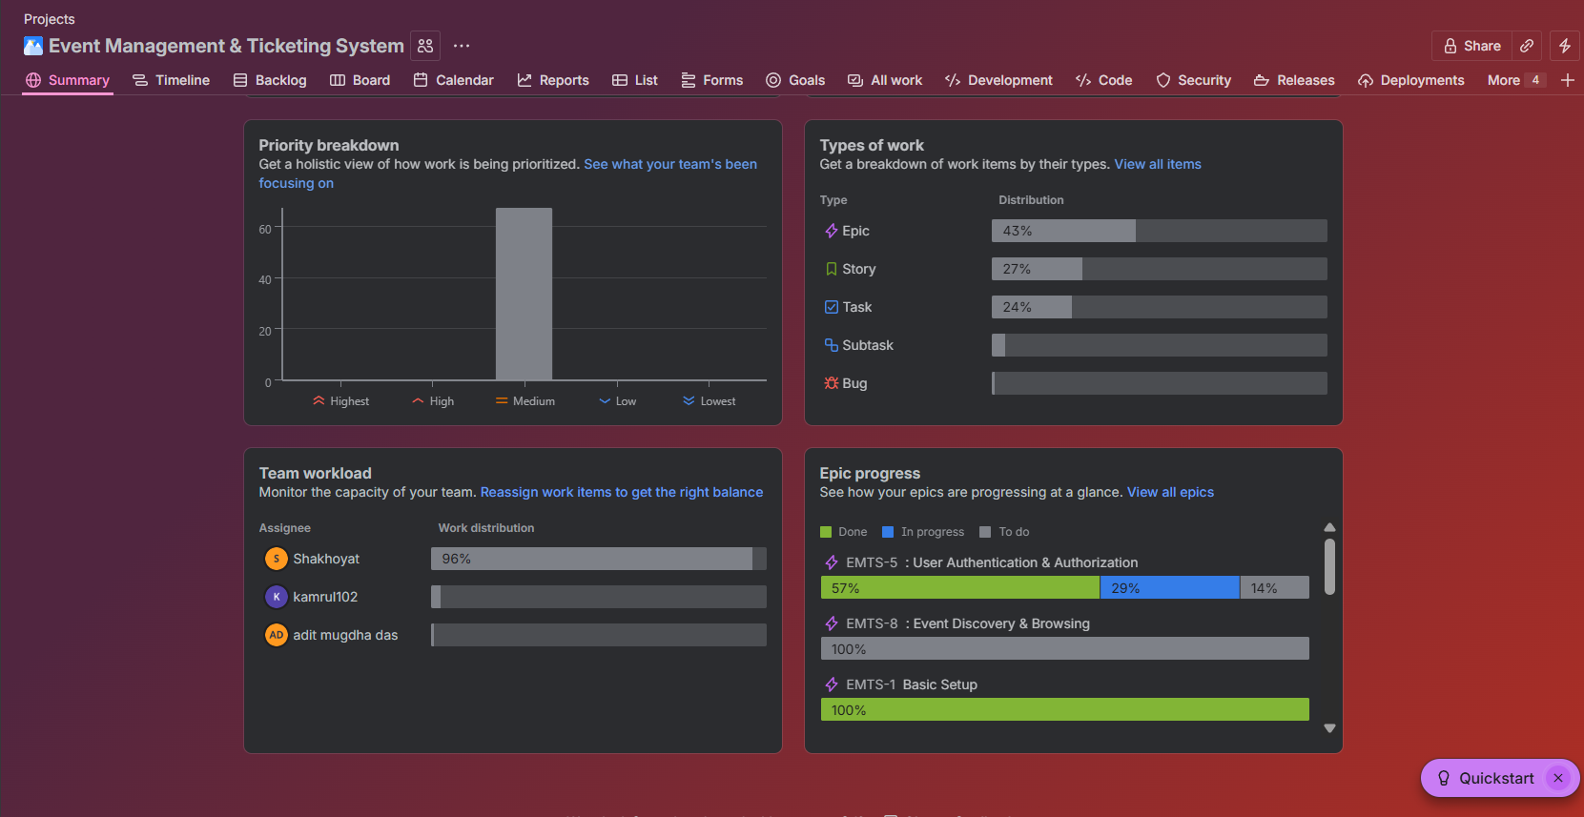

**Figure 25:** Jira Progress Reports (1)

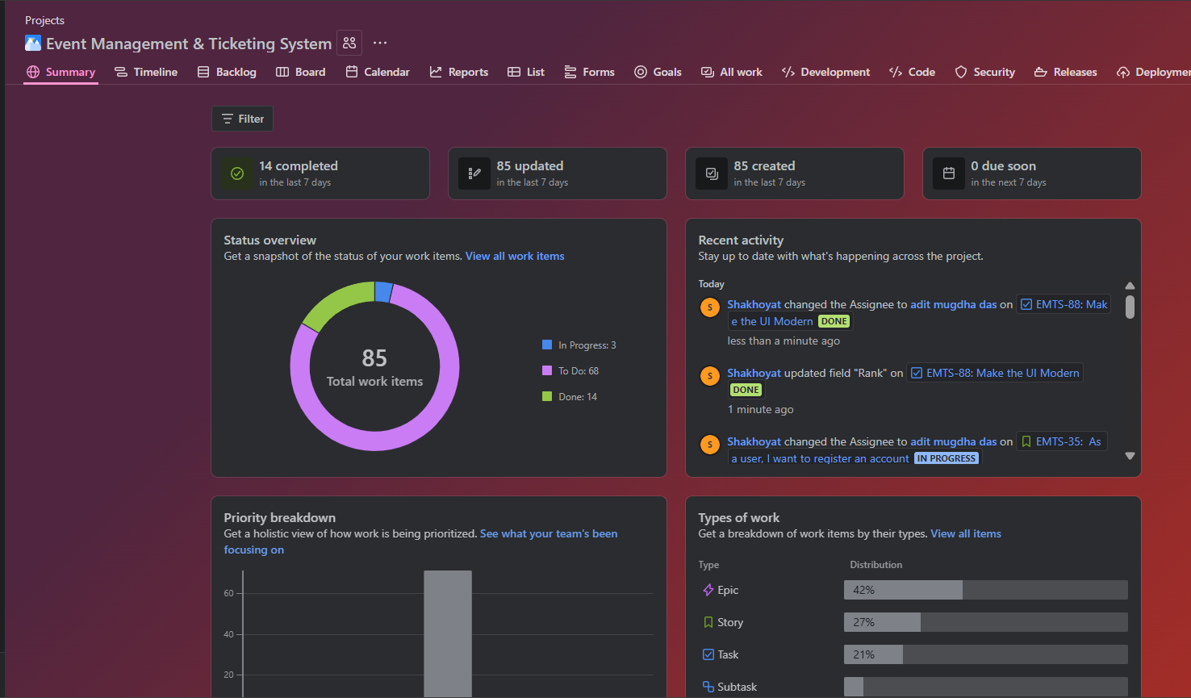

**Figure 26:** Jira Progress Reports (2)

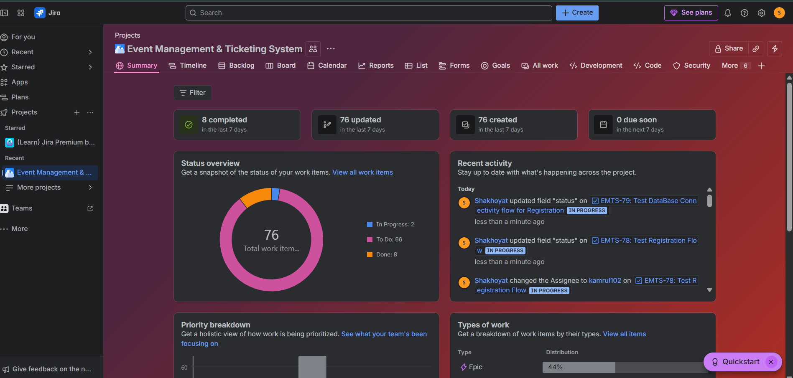

**Figure 27:** Jira Progress Reports Summary

#### **Sprint Burndown Charts**

Each sprint was monitored with a dedicated burndown chart, showing how work hours or story points decreased over time as issues were completed.The steady downward trend across all sprints indicated consistent progress and effective sprint planning.

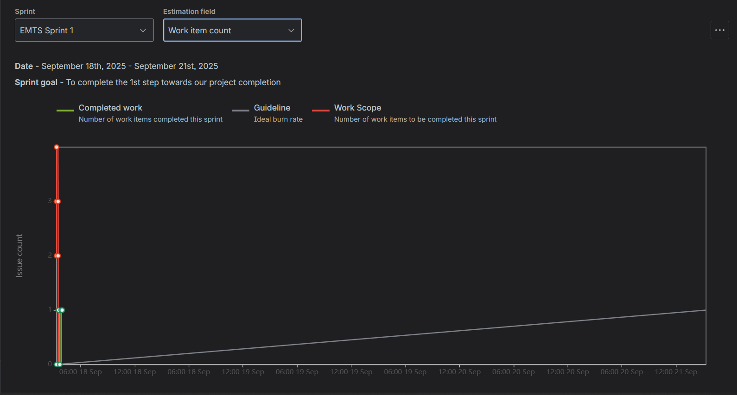

**Figure 28:** *Jira Burndown Charts (Sprints 1)*

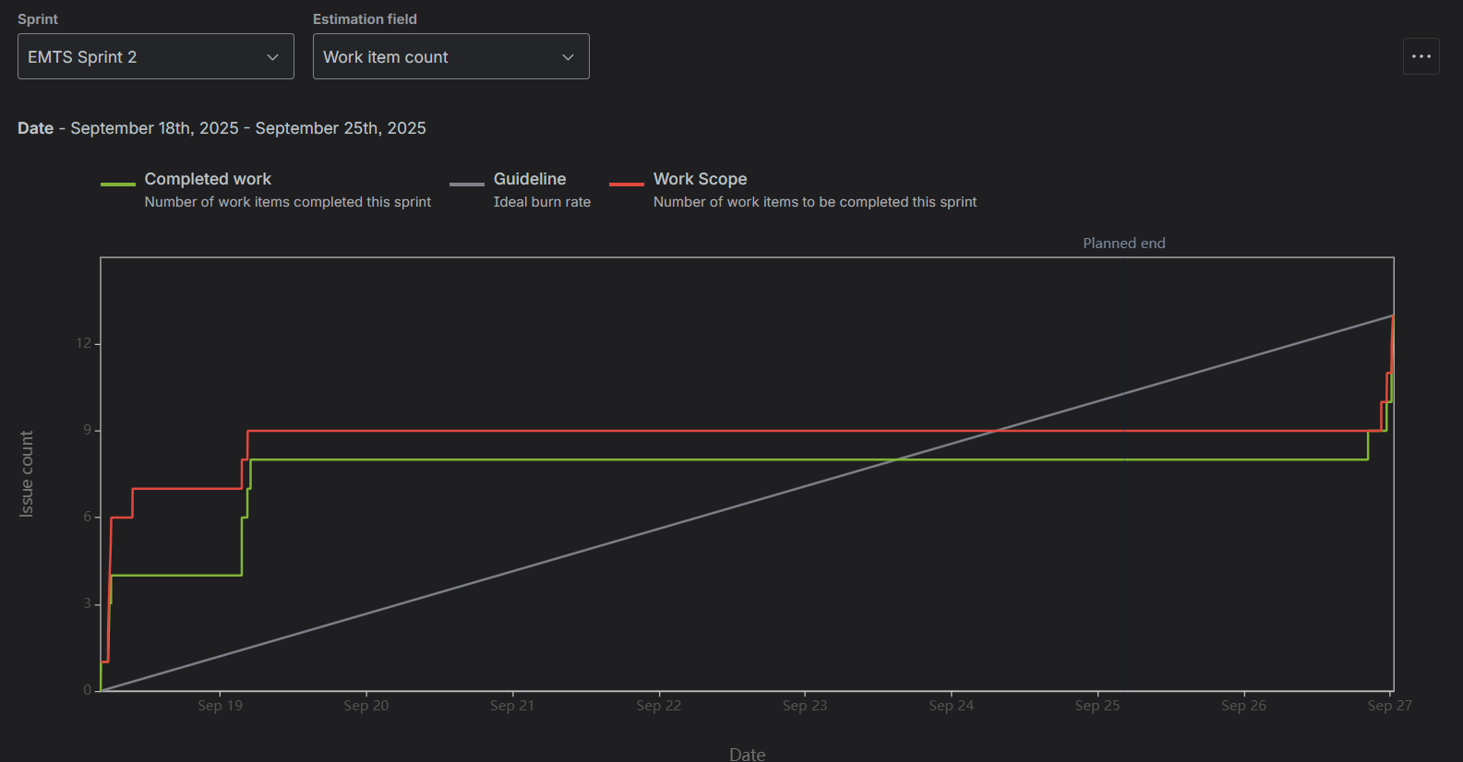

**Figure 29:** *Jira Burndown Charts (Sprints 2)*

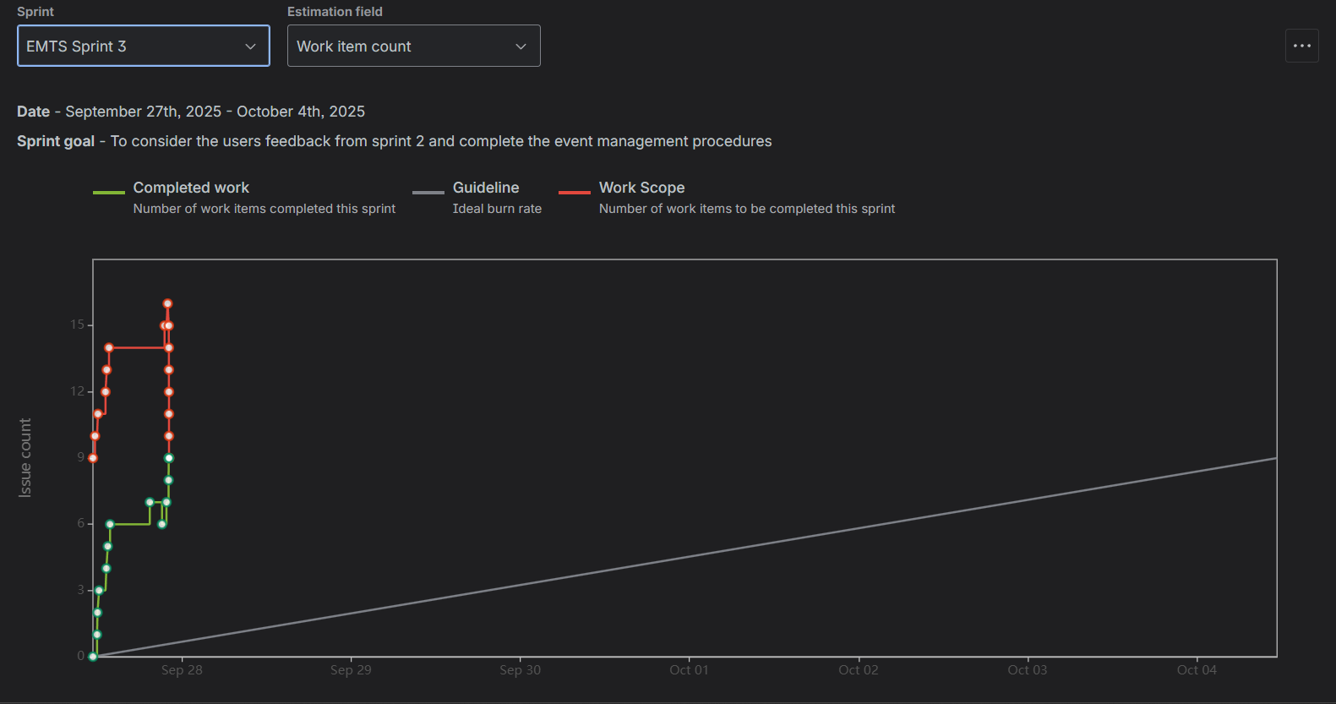

**Figure 30:** *Jira Burndown Charts (Sprints 3)*

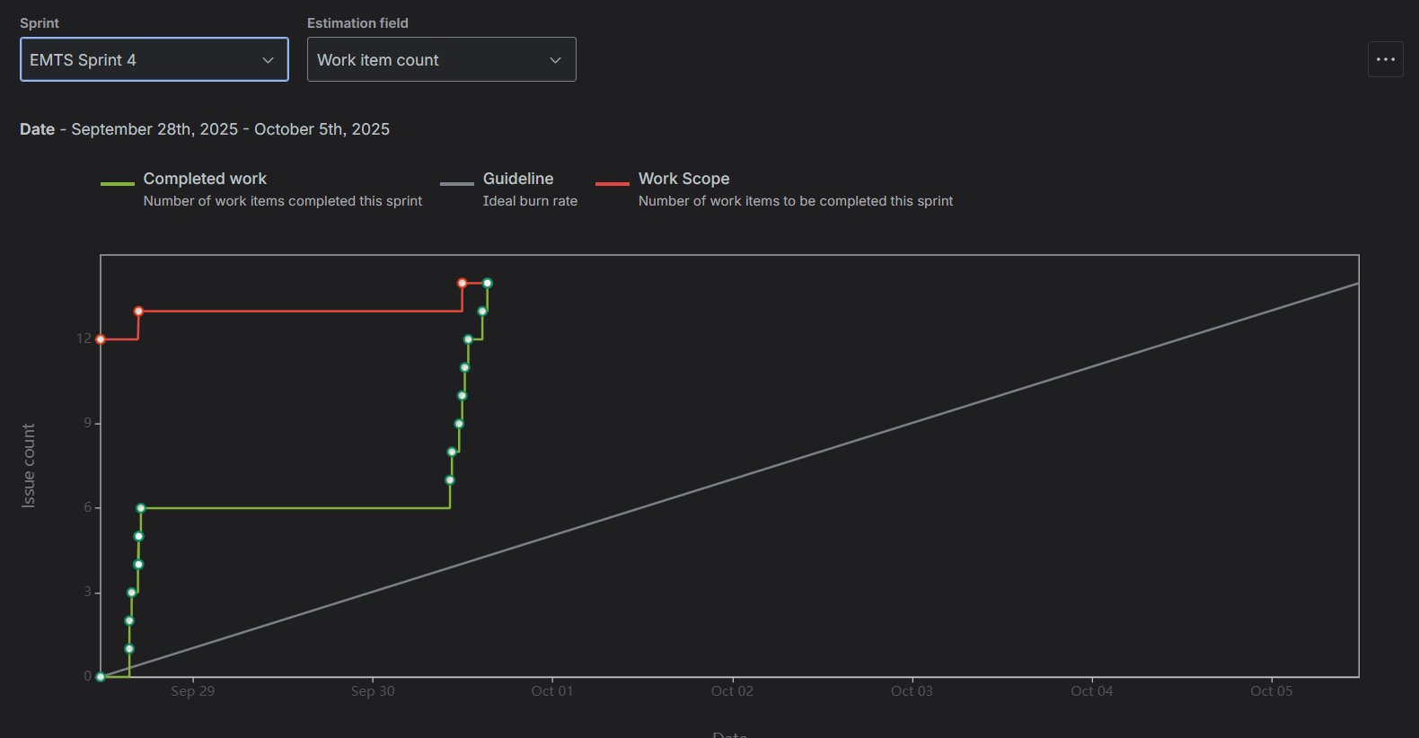

**Figure 31:** *Jira Burndown Charts (Sprints 4)*

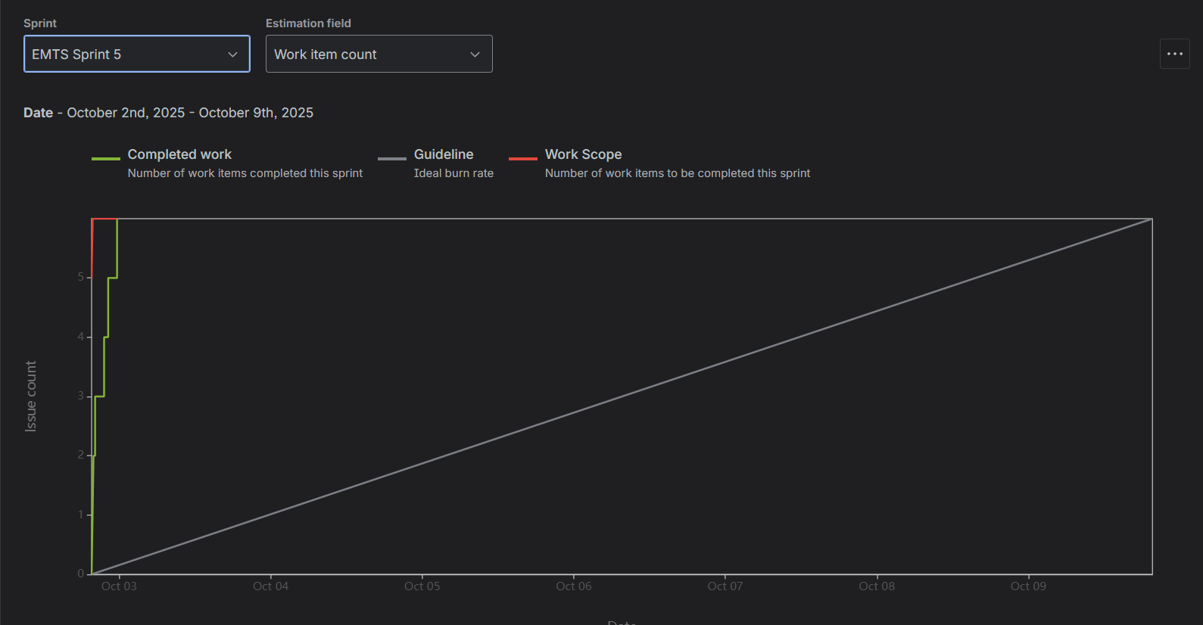

**Figure 32:** *Jira Burndown Charts (Sprints 5)*

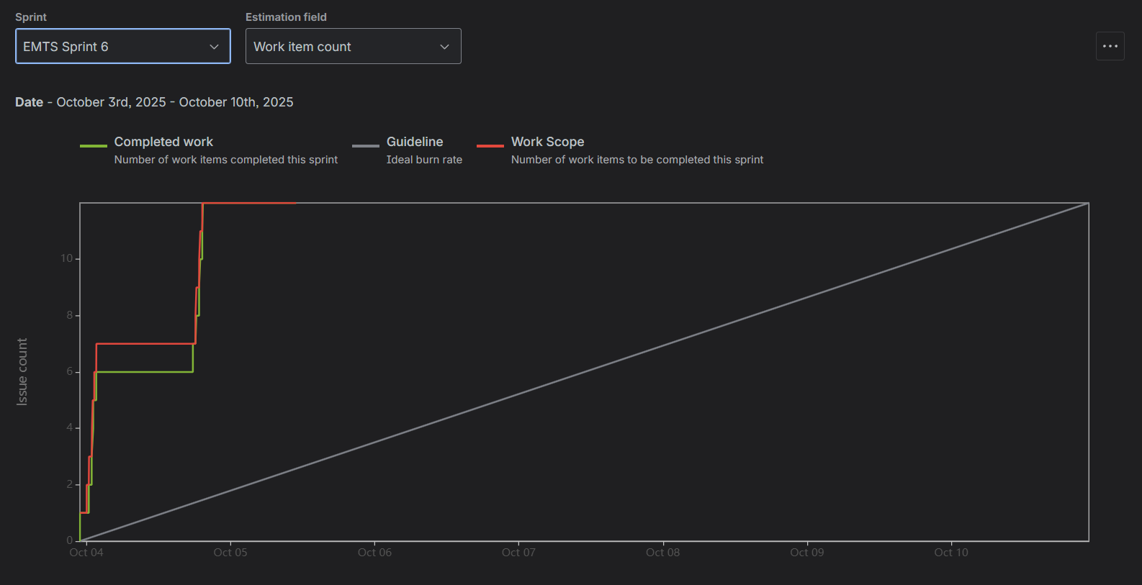

**Figure 33:** *Jira Burndown Charts (Sprints 6)*

#### **Timeline (Gantt) Charts:**

The Timeline Charts offered a visual representation of sprint durations, dependencies, and task overlaps.This ensured proper scheduling and avoided resource conflicts, allowing the team to manage parallel development efficiently.

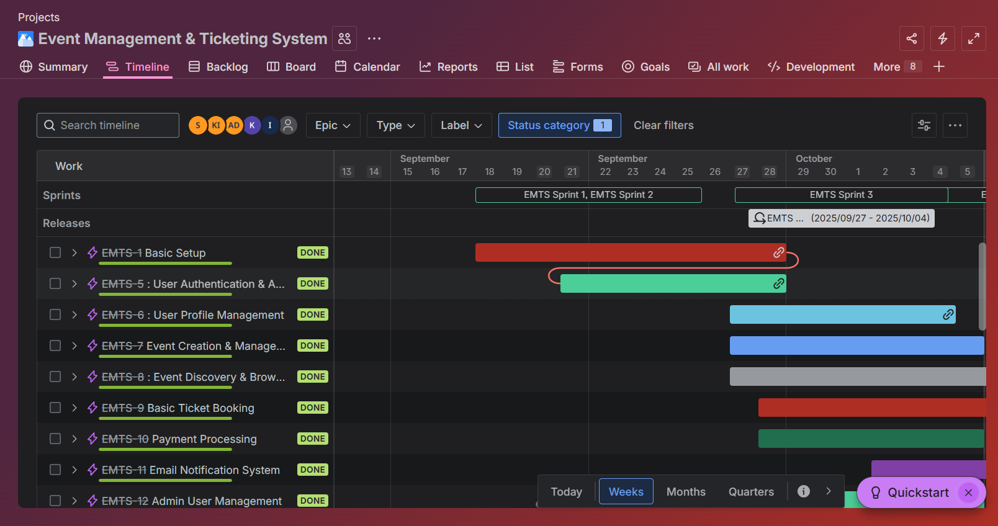

**Figure 34:** Jira Timeline Chart (1)

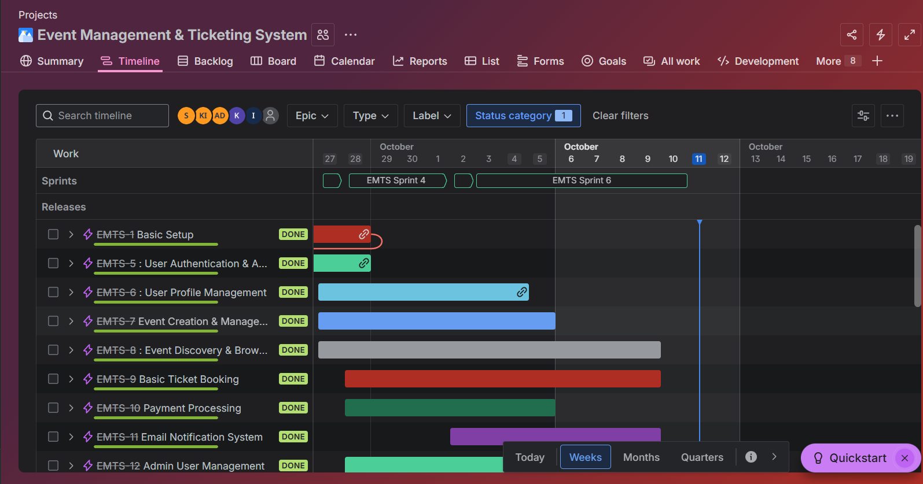

**Figure 35:** Jira Timeline Chart(2)

#### **Cumulative Flow Diagram (CFD):**

### The Cumulative Flow Diagram tracked issue statuses across the development process — from To Do to In Progress, Testing, and Done.It provided insights into workflow stability and helped identify bottlenecks. The steady color distribution demonstrated balanced team performance and smooth sprint transitions.

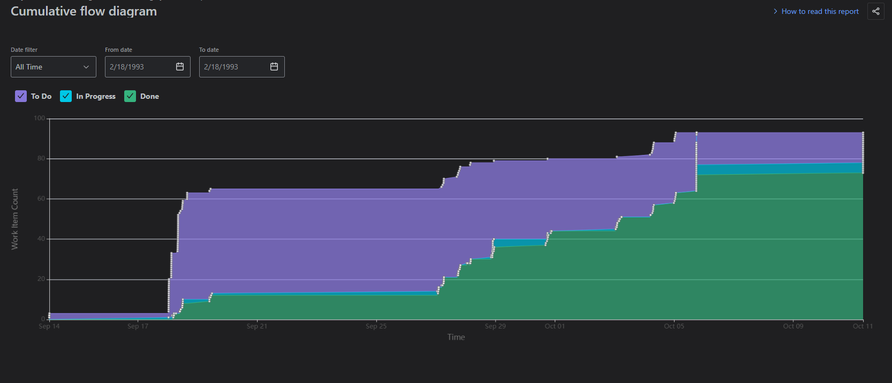

### **Figure 36:** Jira Cumulative Flow Diagram reflecting consistent workflow stability and efficient sprint execution.

#### **Velocity Report**

The Velocity Chart displayed the number of completed story points per sprint, helping the team evaluate its delivery capacity and consistency.It served as a key performance indicator for planning future sprint workloads more accurately.

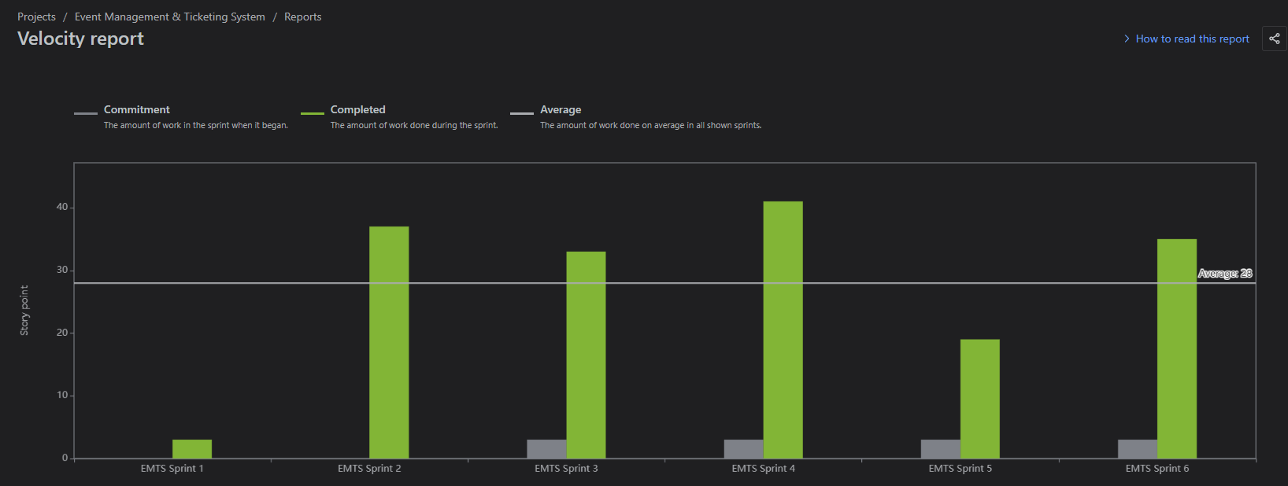

**Figure 37:** Jira Velocity Report highlighting sprint-to-sprint performance and sustainable workload pacing.

## **Discussion:**

The Event Management & Ticketing System (EMTS) project was a collaborative and iterative journey that demonstrated how structured planning and technical design come together to create a real-world solution. The project’s lifecycle from requirement gathering to deployment reflected a disciplined application of the Agile Scrum methodology, ensuring adaptability and continuous improvement at every step.

Using Jira Software as the central management platform allowed us to translate high-level goals into actionable tasks. Each Epic and Story represented a concrete milestone, and the use of dashboards, burndown charts, and velocity reports gave us data-driven insights into our sprint performance. This visualization of progress not only enhanced team coordination but also built accountability, helping every member stay aligned with sprint objectives.

Meanwhile, our GitHub organization functioned as the technical backbone of the development process. Every feature branch corresponded to a Jira task, linking planning with real code implementation. The integration between GitHub and Jira provided full traceability from assigning a task to merging the final pull request ensuring that development, testing, and delivery followed a transparent, version-controlled workflow. Code reviews through pull requests encouraged clean coding practices, peer learning, and quality assurance.

The System Design phase stood out as a turning point, where conceptual requirements evolved into structured architecture. By implementing well-known software design patterns such as Observer, Service Layer, Repository, Strategy, Command, and State, we ensured modularity, reusability, and long-term maintainability. These patterns reduced complexity and made the Laravel codebase easier to extend a critical factor for scalability in event-driven applications.

During the Testing and Maintenance phases, we emphasized continuous validation and improvement. Manual and automated testing, combined with Jira’s bug-tracking system, helped us identify issues early and maintain consistent software reliability. The Jira analytics including burndown charts, progress summaries, and velocity graphs reflected that each sprint closed successfully with measurable outcomes. This data-driven monitoring made our development process predictable, transparent, and professionally aligned with real-world standards.

Overall, EMTS was not just a technical implementation but a well-coordinated project that integrated teamwork, management, and design thinking into a cohesive workflow.

## **Conclusion:**

The Event Management & Ticketing System (EMTS) embodies a complete, end-to-end software development effort grounded in structured methodology and teamwork. From requirements analysis to system deployment, every phase of the SDLC was executed with precision and mutual collaboration.

This project taught us how successful software engineering extends beyond coding it relies equally on planning, design, communication, and continuous evaluation. Through the combination of Jira’s project management capabilities and GitHub’s version control, we maintained an efficient feedback loop where each iteration built upon the last. This ensured not only functional completion but also code quality, accountability, and consistency.

The inclusion of design patterns made our Laravel-based architecture robust, modular, and scalable. Each component from authentication and event management to ticketing and notifications worked independently yet cohesively, demonstrating strong object-oriented design principles. This structured approach made the project easy to maintain and adaptable for future enhancements.

In conclusion, EMTS stands as a testament to effective teamwork, disciplined Agile execution, and professional engineering practices. It reflects how a well-managed SDLC can transform ideas into a reliable, real-world application. Beyond the technical achievements, the project strengthened our collaboration, problem-solving, and analytical skills preparing us for the challenges of real-world software development environments.

## **References:**

1. Atlassian. Jira Software Documentation – Agile Project Management with Scrum.  
    Retrieved from https://www.atlassian.com/software/jira
2. GitHub, Inc. GitHub Documentation – Managing Branches and Pull Requests.  
    Retrieved from https://docs.github.com/
3. Laravel. Laravel Framework Documentation (v10.x).  
    Retrieved from<https://laravel.com/docs>
4. Tailwind Labs. Tailwind CSS – Utility-First CSS Framework Documentation.  
    Retrieved from<https://tailwindcss.com/docs>
5. Sommerville, I. (2016). *Software Engineering (10th Edition)*. Pearson Education.
6. Beck, K., & Fowler, M. (2001). *Planning Extreme Programming*. Addison-Wesley Professional.